**JAYPEE INSTITUTE OF INFORMATION TECHNOLOGY, NOIDA**

**B.TECH SEMESTER 1**

**REPORT FOR MINI PROJECT**



**TITLE OF THE PROJECT**

SCIENTIFIC CALCULATOR AND UNIT CONVERTOR

**SUPERVISION OF: SUBMITTED BY:**

**Dr. Himansu Sekhar and** ENROLL NO. NAME

**Dr. Parul Agarwal** JEG226327 Saksham Singh Rawat

Assistant Professor(Senior Grade) JEG220481 Sankalp Goyal

Department of Computer science JEG221646 Ayush Singh

Engineering JIIT,Sector 62 Noida.

**ABOUT THE PROJECT**

**AIM:**

The aim of the project is to create a program that is capable of performing various mathematical calculations with and without using inbuilt functions. In addition, the program is also provided with a teacher mode and some basic unit convertors.

This program caters to the variety of multitudinous functions of different mathematical operations and various units of interconversion to give a multifarious program.

**OBJECTIVES:**

The code translates system requirements into ways by which they can be made operational. The objective is to build a user interactive calculator to fulfil various commonly used mathematical operations. At the same time, it also has inbuilt functions for inter conversion of some basic units.

**FEATURES:**

“Scientific Calculator and Convertor” has been designed to computerize the following functions that are performed by the system:

* Input user details - User is able to select the desired functions to be performed and the appropriate results will be displayed at the end.
* Versatility - Basic mathematical calculations, algebraic operations, trigonometric operations, exponential operations and number system conversion, all can be calculated at users’ choice.
* Convertor - Most commonly used units of length, mass and currencies can be converted from one unit to the other.

**CONCEPTS USED:**

* Arrays
* Recursion
* Pointers
* Structures
* Switch
* If- else
* Conditional structure (if, if-else, nested if)
* File handling
* Various header files

**BASIC WORKING OF PROGRAM:**

The program is divided into two parts:-

* Calculator
* Teacher mode
* Convertor

**Calculator:**

* Basic mathematical calculations

--Addition

--Subtraction

--Multiplication

--Division

--Modulus

* Algebraic operations

--Factorial

--Power

--Permutation

--Combination

* Trigonometric functions

--Sine

--Cosine

--Tangent

--Hyperbolic sine

--Hyperbolic cosine

--Hyperbolic tangent

* Exponential functions

--Logarithm

--Base 10 logarithm

--Inverse logarithm

--**eˣ**

* Number system conversion

--Decimal to binary and vice versa

--Decimal to octal and vice versa

--Decimal to hexadecimal and vice versa

* Teacher mode

--Sum

--Average

--Percentage

--Highest marks scored

--Lowest marks scored

**Teacher mode:**

* Teacher mode

--Sum

--Average

--Percentage

--Highest marks scored

--Lowest marks scored

**Convertor:**

* Unit convertor

--Length

--Mass

--Time

--Currency

**ALGORITHM:**

1. Start.
2. Display the options on the screen.
3. Print “welcome to interface” and the menu

|  |
| --- |
| ENTER 1 FOR CALCULATOR |
|  |
| ENTER 2 FOR CONVERTOR |

4. If the user chooses CALCULATOR, then print the following menu:

|  |
| --- |
| ENTER 1 FOR BASIC MATHEMATICAL CALCULATIONS |
|  |
| ENTER 2 FOR ALGEBRAIC OPERATIONS |
|  |
| ENTER 3 FOR TRIGONOMETRIC OPERATIONS |
|  |
| ENTER 4 FOR EXPONENTIAL OPERATIONS |
|  |
| ENTER 5 FOR NUMBER STSYEM CONVERSION |
|  |
| ENTER 6 FOR TEACHER MODE |
|  |
| ENTER 7 FOR MATRIX OPERATIONS |

5. Now if MATHEMATICAL CALCULATIONS is chosen by the user, then the program asks for the count of number on which the operations are to be performed and prints the following menu:

|  |
| --- |
| ENTER 1 FOR ADDITION |
|  |
| ENTER 2 FOR SUBTRACTION |
|  |
| ENTER 3 FOR MULTIPLICATION |
|  |
| ENTER 4 FOR DIVISION |
|  |
| ENTER 5 FOR MODULUS |

6. Now as per the user’s choice, respective operations are performed by the program by calling of the respective functions created using arrays.

7. If the user chooses ALGEBRAIC OPERATIONS the program prints the following menu:

|  |
| --- |
| ENTER 1 FOR FACTORIAL |
|  |
| ENTER 2 FOR POWER |
|  |
| ENTER 3 FOR PERMUTATION AND COMBINATION |

8. Now as per the user’s choice, respective operations are performed by the program by calling of the respective functions created using recursion.

9. if the user chooses TRIGONOMETRIC OPERATIONS, the following menu is printed:

|  |
| --- |
| ENTER 1 FOR SINE |
|  |
| ENTER 2 FOR COSINE |
|  |
| ENTER 3 FOR TANGENT |
|  |
| ENTER 4 FOR HYPERBOLIC SINE |
|  |
| ENTER 5 FOR HYPERBOLIC COSINE |
|  |
| ENTER 6 FOR HYPERBOLIC TANGENT |

10. Now as per the user’s choice, the program asks for the value of angle and the respective operations are performed by the program by calling of the respective functions using predefined functions.

11. if user chooses EXPONENTIAL OPERATIONS, the program prints the following menu:

|  |
| --- |
| ENTER 1 FOR LOGARITHM |
|  |
| ENTER 2 FOR LOGARITHM BASE 10 |
|  |
| ENTER 3 FOR **eˣ** |
|  |
| ENTER 4 FOR INVERSE LOGARITHM |

12. Now as per the user’s choice, the program asks for numbers as input and the respective operations are performed by calling of the respective functions using predefined functions and manual functions created.

13. if the user chooses NUMBER SYSTEM CONBERSION, then the program prints the following menu:

|  |
| --- |
| ENTER 1 FOR DECIMAL TO BINARY |
|  |
| ENTER 2 FOR BINARY TO DECIMAL |
|  |
| ENTER 3 FOR DECIMAL TO OCTAL |
|  |
| ENTER 4 FOR OCTAL TO DECIMAL |
|  |
| ENTER 5 FOR DECIMAL TO HEXADECIMAL |
|  |
| ENTER 6 FOR HEXADECIMAL TO DECIMAL |

14. Now if the user chooses COVERTOR, program prints the following menu:

|  |
| --- |
| ENTER “length” TO ACCESS THE LENGTH CONVERTOR |
|  |
| ENTER “mass” TO ACCESS THE MASS CONVERTOR |
|  |
| ENTER “time” TO ACCESS THE TIME CONVERTOR |
|  |
| ENTER “currency” TO ACCESS CURRENCY CONVERTOR |

15. Now upon entering the required unit, the program prints the units acceptable and their format. Now the user has to enter the magnitude and unit of the input. Then the user has to enter the unit into which it has to be converted. Upon entering the required values, the program gives appropriate result using concepts of file handling and strings.

16. If the user chooses TEACHER MODE, then the program asks for the number of users, when you input some value, the program prints the following menu:

|  |
| --- |
| ENTER THE ENROLLMENT NUMBER OF THE STUDENT |
|  |
| ENTER MARKS IN MATHS |
|  |
| ENTER MARKS IN PHYSICS |
|  |
| ENTER MARKS IN ENGLISH |
|  |
| ENTER MARKS IN SOFTWARE DEVELOPMENT FUNDAMENTALS |
|  |
| ENTER MARKS IN BRIDGE COARSE |
|  |
| ENTER MARKS IN SDF LAB |

17. Now upon entering the following values the program prints the following menu:

|  |
| --- |
| ENTER 1 TO FIND SUM OF MARKS |
|  |
| ENTER 2 TO FIND AVERAGE MARKS |
|  |
| ENTER 3 TO FIND PERCENTAGE |
|  |
| ENTER 4 TO FIND HIGHEST MARKS SCORED |
|  |
| ENTER 5 TO FIND LOWEST MARKS SCORED |

18. Now when user enters any choice, the program gives appropriate result.

19. At the end of the program, the program asks the user to enter 1 to rerun the program from the beginning.

**OUTPUT WINDOW:**

Output window at the starting of the program is:-



If user inputs 1 then :

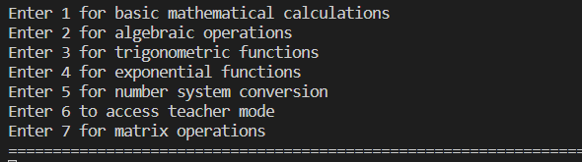

Now suppose user enters 1:

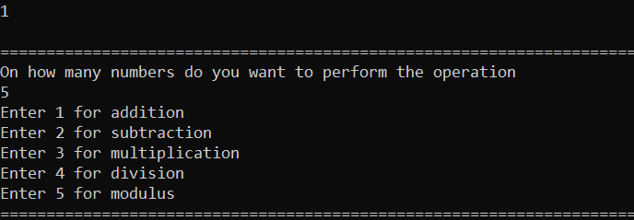

Now suppose user wants to multiply 5 numbers then he enters 3:

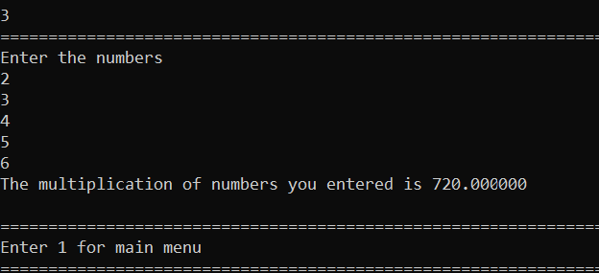

Now for algebraic operations if the user wants to calculate power of a number to another number, then :

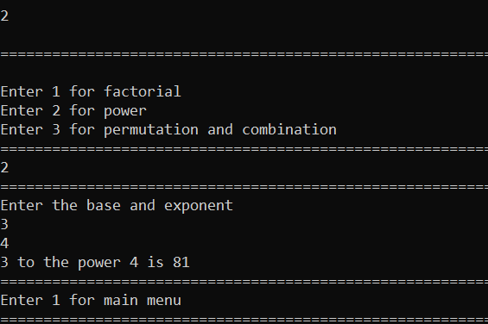

Now if the user wants to calculate hyperbolic cosine of 46.8 degrees, the :

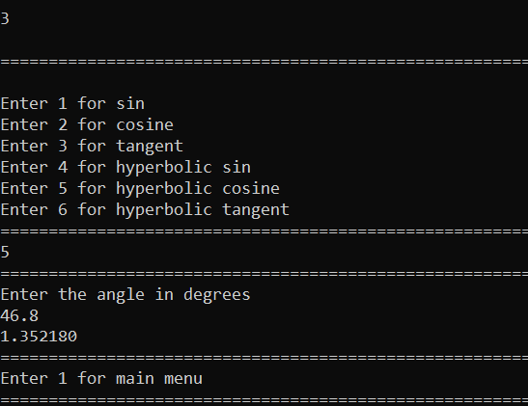

Now if the user wants to convert decimal number to hexadecimal, then: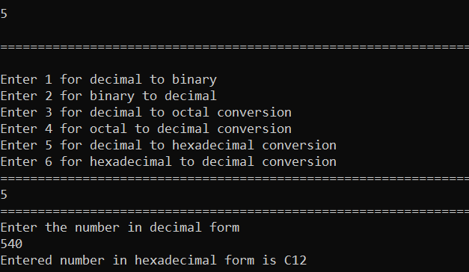

Now if the user wants to multiply two matrices, then :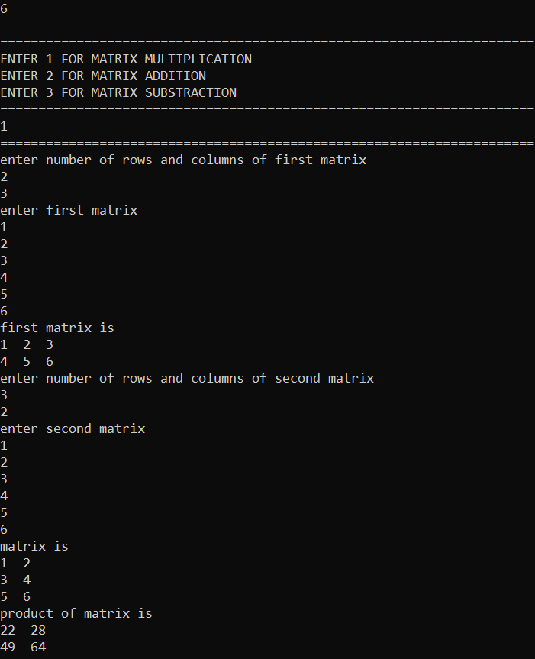

Now if the user wants to convert one length unit to another:

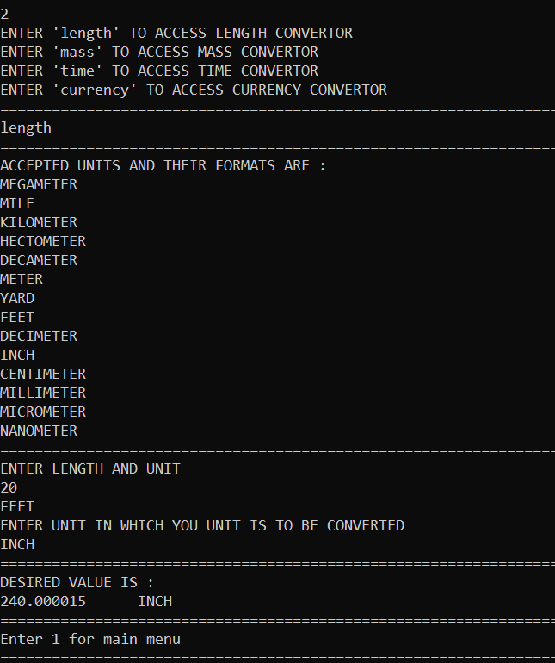

Such conversions can also be made for three other units which are mass, time and currency.

The working of the teacher mode is as follows :

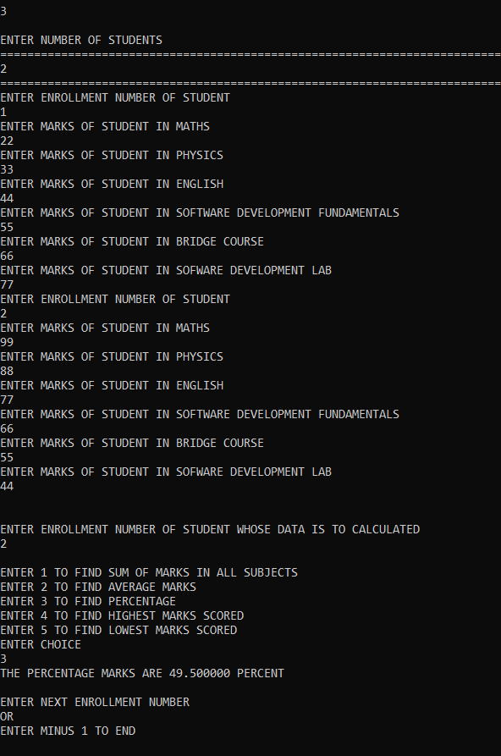

**REFRENCES:**

* <https://www.geeksforgeeks.org/>
* <https://www.programiz.com/c-programming>
* <https://www.w3schools.com/c/c_intro.php>
* <https://www.javatpoint.com/c-programming-language-tutorial>